**Bandits Character Designs**

General Visuals:

* Spy/ninja gear
  + Headbands or armbands with colors
  + ~~watches~~
  + ~~head gear~~
* Different personalities:
  + ~~Sherlock holmes raccoon?~~
  + Kool: narcissistic raccoon (male)
    - always seeking ways to enhance appearance, even if it may mean trying on the most ridiculous outfits
    - hates looking stupid
    - think of an aristocrat
    - moves more carefully than the others
    - 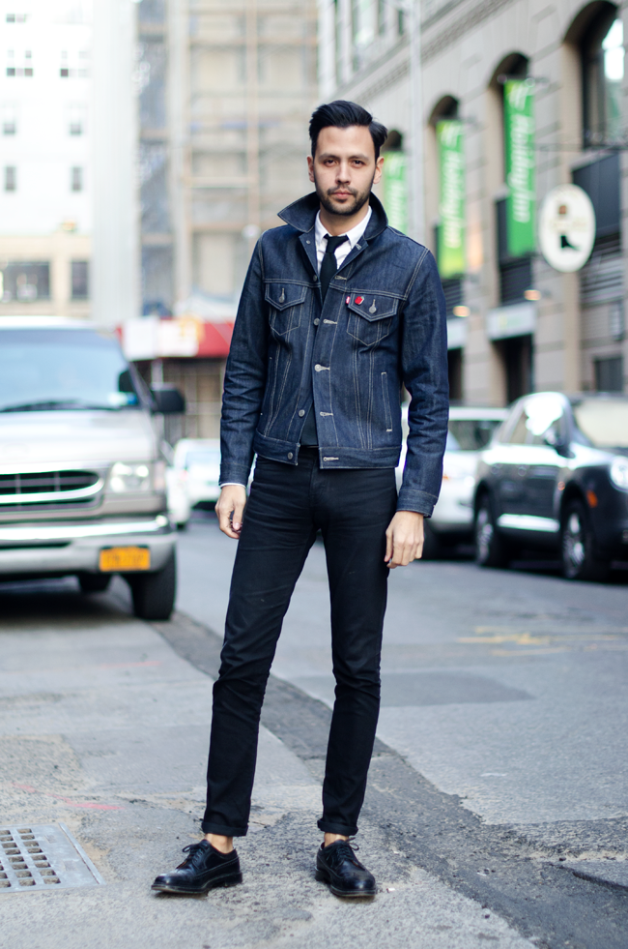
    - 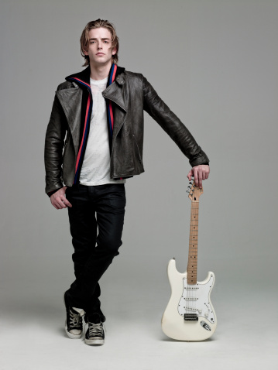
  + Vaingana: vain raccoon (female)
    - always seeking ways to enhance appearance, even if it may mean trying on the most ridiculous outfits
    - hates looking stupid
    - think of an aristocrat
    - moves more gracefully and carefully than the others (think of ballet)
    - 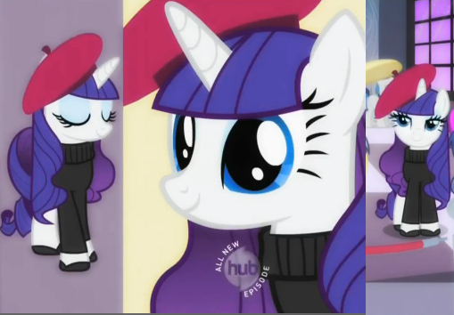
    - 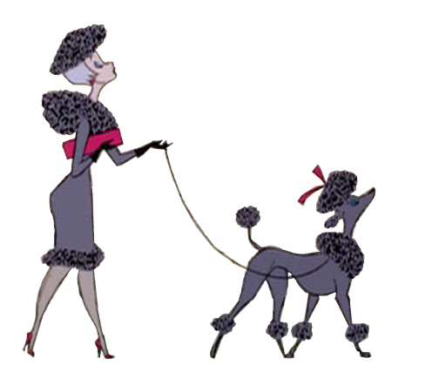
  + Sneaks: gastronomical raccoon (skinny, unexpected)
    - eats all the time, but never seems to get bigger
    - has super-quick metabolism
    - Has a fanny pack that seems to contain cool spy gadgets, but actually contains snacks (cat food, nuts, cookies, wafers, Cheetos, cheerios, Lucky Charms) -> likes to maintain image of sophisticated spy/ninja instead of a food junkie
    - plays around with food and creates lovely raccoon concoctions in secret
    - when someone comes into the scene of its raccoon concoction creation, it quickly stuffs the creation in its mouth and gobbles it down before it gets discovered
    - 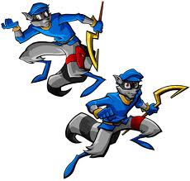
    - 
    - 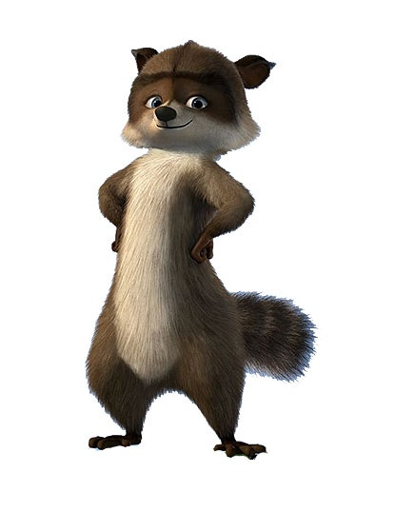
  + Gorgeon: overweight raccoon (fat, traditional)
    - eats all the time
    - has round belly
    - Always carries around a bag of snacks to munch on
    - plays around with food and creates lovely raccoon concoctions
    - always has crumbs around its mouth
    - when it’s time for action, it stuffs its mouth and gobbles as it runs
    - when snacks run out, it searches behind its ears for leftovers (sometimes finds crumbs)
    - surprisingly nimble/dextrous in its own way
    - 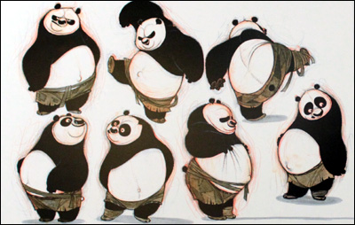
    - 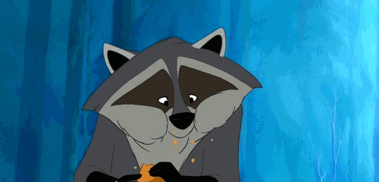
  + TUFF: fit raccoon (bulky)
    - large, square character
    - loves to show off its muscles
    - can lift large objects (i.e. a twin-sized bed)
    - think: boxing champ
    - wreck-it-ralph
    - lumbering around, movement
    - 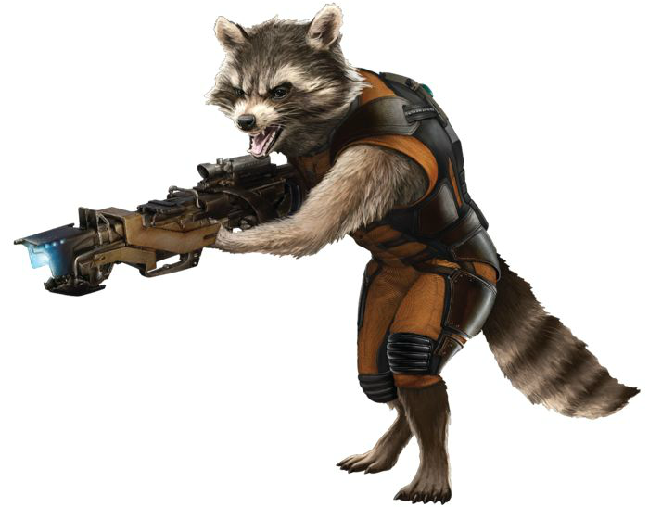
  + Nimblina: fit raccoon (skinny)
    - runner/ninja
    - nimble and moves like Tigress from Kung Fu Panda
    - loves to perform stunts
      * jump backwards into handstand and back onto feet again (can do multiple in a row)
    - 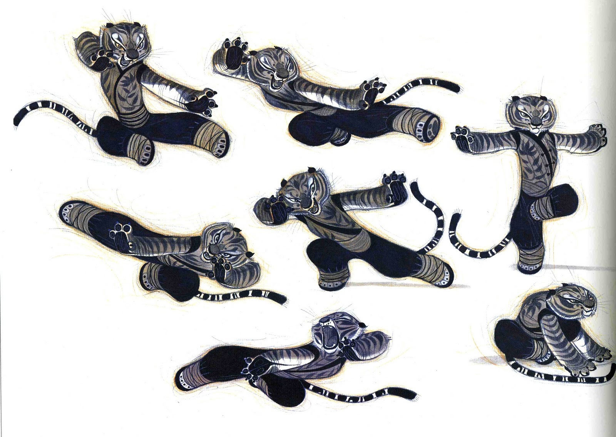

First Round:

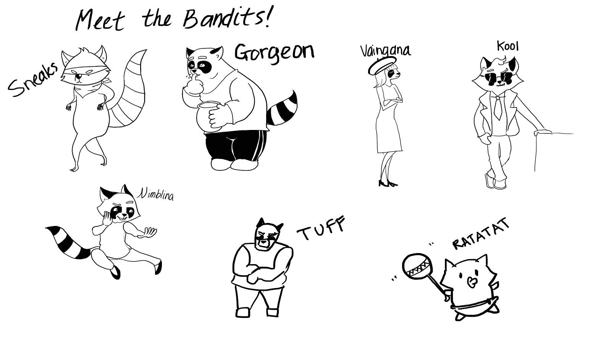

Second Round:

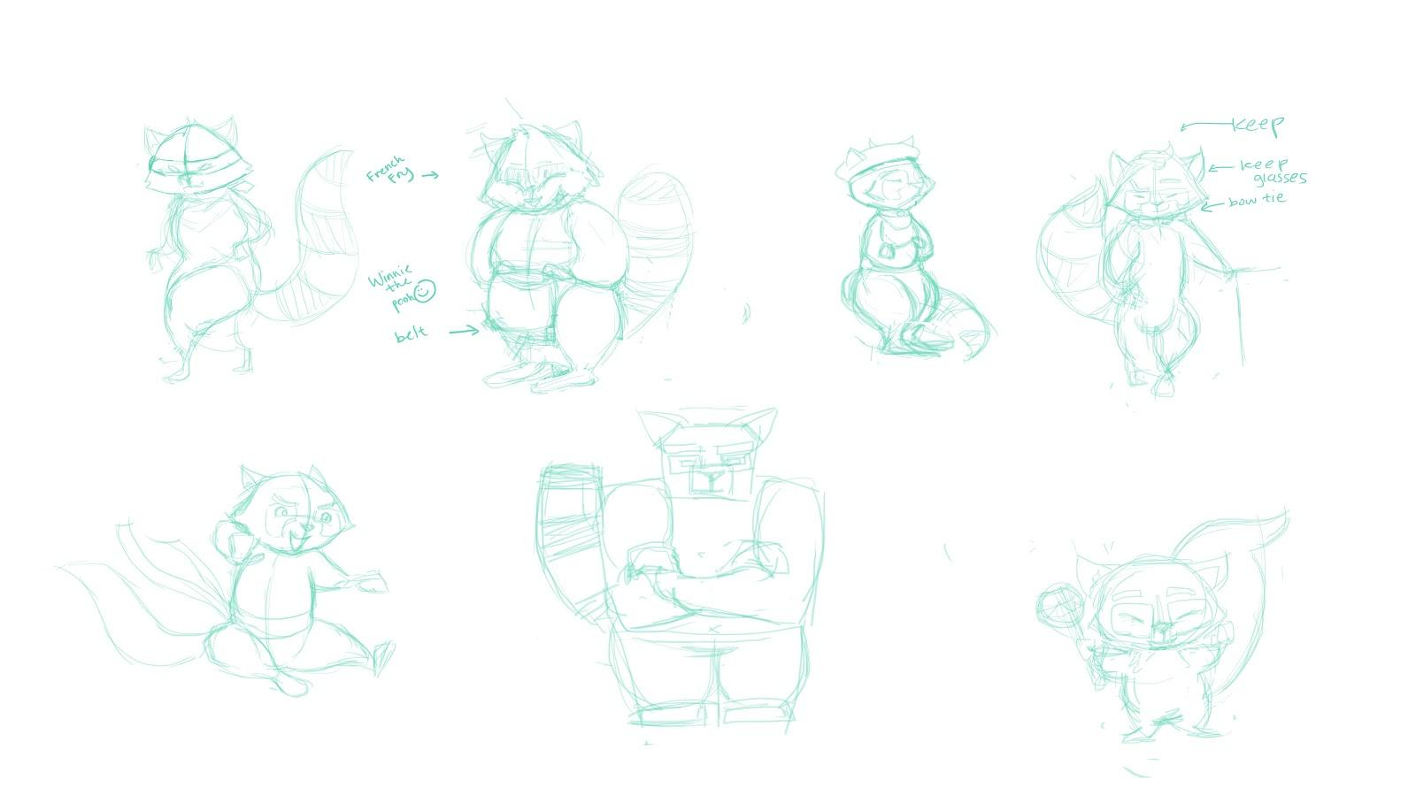

Third Round: (Draw-overs by Alishea :D)

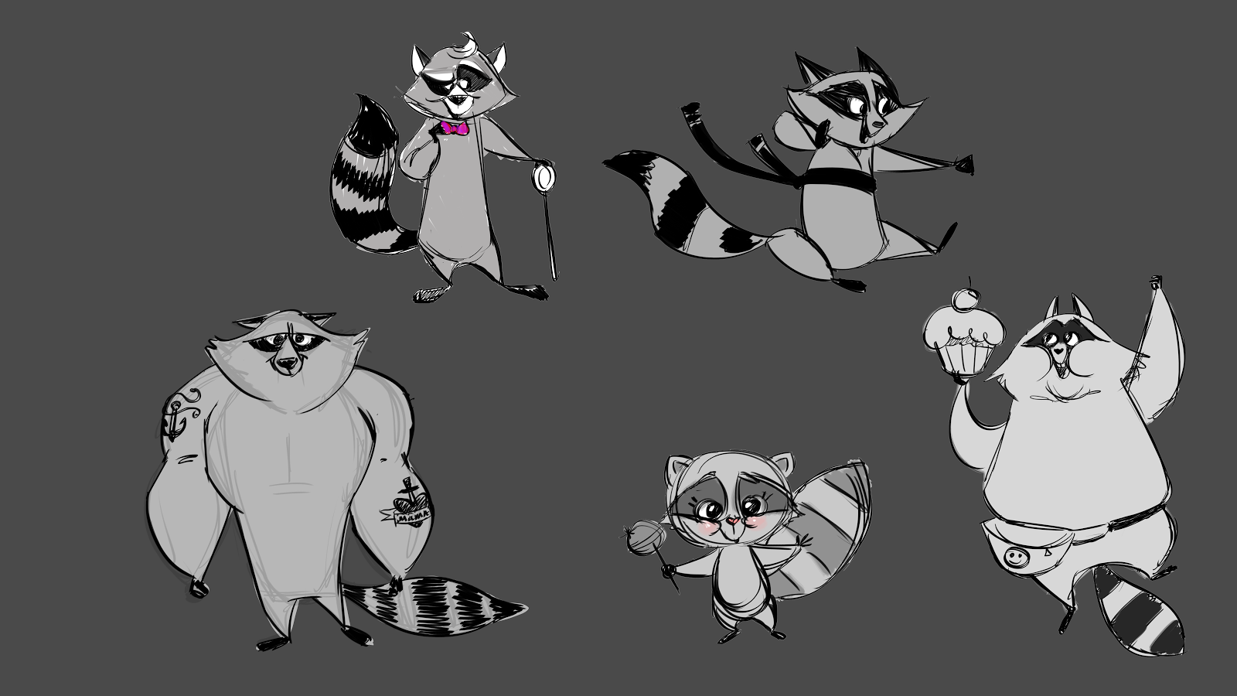

Fourth Round:

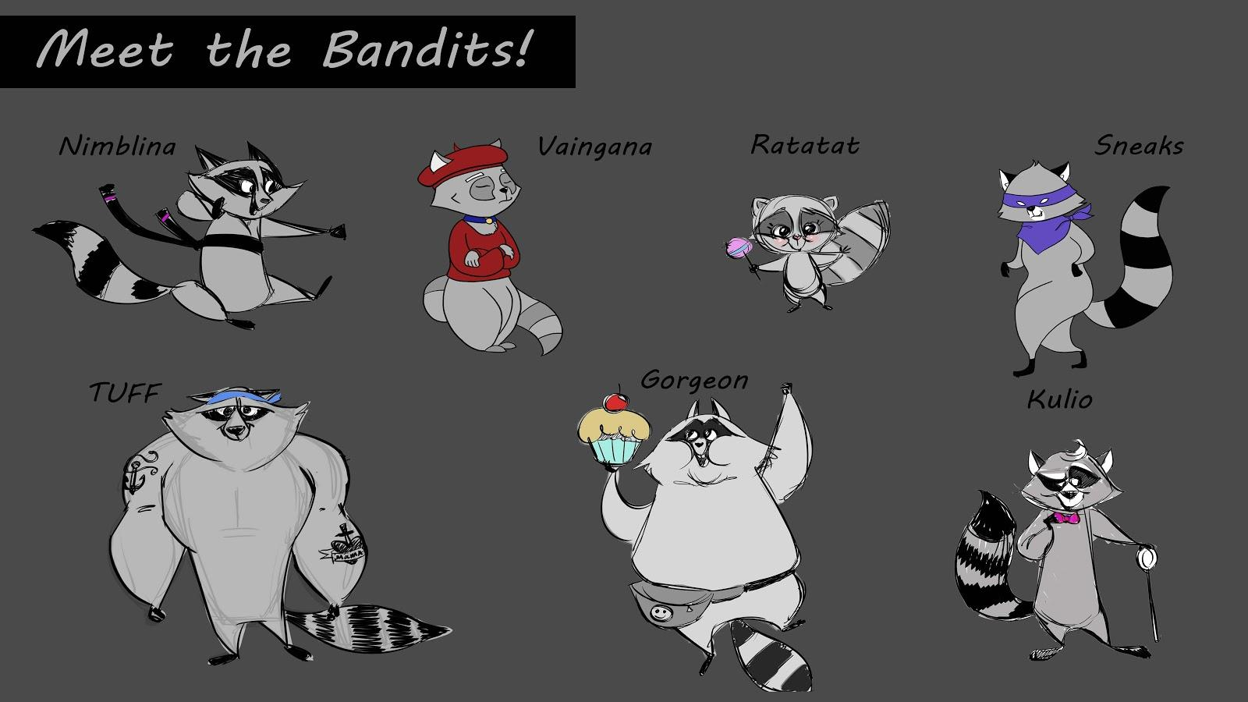

Actions:

* **Vain raccoon Trying on tuxedo, sunglasses, sunhat (clothesline?) OR laundry thing -> embarrassment?**

**Take bubble baths - rubber duck!!**

**Eating with fork/knife/chopsticks**

Stealing cat food

Stealing milk bottles/something else (baby raccoons)

**Stealing socks from dryer**

Stealing pencils/practicing writing

Parachuting away

Raccoons escaping out window: more dynamic angle? e.g. sliding down posts, rails… split camera shot

do somersaults; exit from first-floor window and then transition to front door

Post-credits: bonus scene

Raccoon in tuxedo as James Bond?

Raccoons in tree house with all their stuff

**Questions**

walkie talkie?

daytime or nighttime

camera angle for closing scene: from car perspective?

**best way to end short?Concept Art & Character Design References**

**Raccoon (**fat/skinny, hair, fur pattern):

**Best Ref:**

[rolling](http://s3-ec.buzzfed.com/static/2014-06/21/17/enhanced/webdr08/anigif_enhanced-31598-1403386111-1.gif) (exit movement?)

[in sink](http://static.gotpetsonline.com/pictures-gallery/small-animal-pictures-breeders-babies/raccoon-pictures-breeders-babies/pictures/raccoon-0026.jpg) (maybe this could be the “bathtub”?

[eating food](http://s3-ec.buzzfed.com/static/2014-06/21/17/enhanced/webdr10/anigif_enhanced-16257-1403387008-1.gif)

[sitting on couch](http://s3-ec.buzzfed.com/static/2014-06/21/17/enhanced/webdr04/anigif_enhanced-27654-1403385337-1.gif)

<http://www.buzzfeed.com/lindseyrobertson/secret-agent-raccoons#2qtfvl>

<https://www.youtube.com/watch?v=jayXKAr4Gmk> (inching cat @ 2:55)

[more raccoon buzzfeed gifs](http://www.buzzfeed.com/erinchack/17-reasons-raccoons-should-be-your-favorite-animal#2qtfvl)

**Meh:**

[wearing hat](http://s3-ec.buzzfed.com/static/2014-06/21/17/enhanced/webdr09/anigif_enhanced-23255-1403385455-3.gif)

[tuxedo raccoon](http://aboutcolonblank.com/wp-content/uploads/2013/10/Raccoon-wearing-a-tuxedo.jpg) (keep?)

[in bird bath](http://www.thepetcollective.tv/wp-content/uploads/2013/07/hot-raccoon-in-bird-bath.jpg) (potential gag…?)

**Other general raccoon references:**

[field guide to animated raccoon](http://thefilmexperience.net/blog/2014/7/31/tims-toons-a-field-guide-to-animated-raccoons.html)

[I like this raccoon's eyebrows](https://www.google.com/search?q=The+Nut+Job&es_sm=119&biw=1091&bih=683&tbm=isch&source=lnms&sa=X&ei=ilwXVPTQE4T7oQTXl4H4Bg&ved=0CAcQ_AUoAg#tbm=isch&q=The+Nut+Job+raccoon)